Practical No 2

AIM: Perform the Extraction Transformation and Loading (ETL) process to construct the database in the Sql server.

ETL Process in Data Warehouses
ETL is a 3-step process
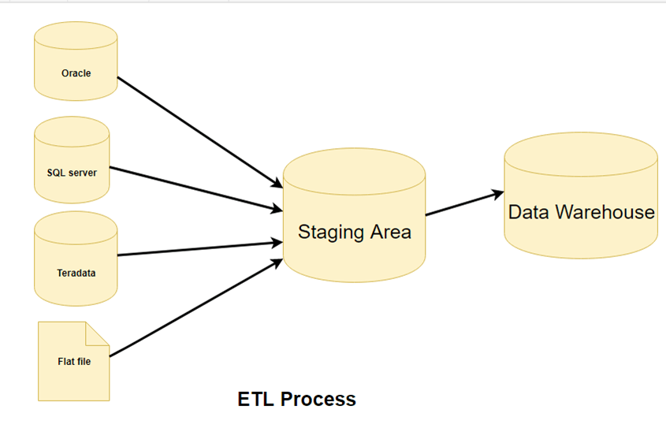ETL Process

Step 1) Extraction
In this step of ETL architecture, data is extracted from the source system into the staging area. Transformations if any are done in staging area so that performance of source system in not degraded. Also, if corrupted data is copied directly from the source into Data warehouse database, rollback will be a challenge. Staging area gives an opportunity to validate extracted data before it moves into the Data warehouse.
Data warehouse needs to integrate systems that have different
DBMS, Hardware, Operating Systems and Communication Protocols. Sources could include legacy applications like Mainframes, customized applications, Point of contact devices like ATM, Call switches, text files, spreadsheets, ERP, data from vendors, partners amongst others.
Hence one needs a logical data map before data is extracted and loaded physically. This data map describes the relationship between sources and target data.
Three Data Extraction methods:
- Full Extraction
- Partial Extraction- without update notification.
- Partial Extraction- with update notification
Irrespective of the method used, extraction should not affect performance and response time of the source systems. These source systems are live production databases. Any slow down or locking could effect company’s bottom line.
Some validations are done during Extraction:
- Reconcile records with the source data
- Make sure that no spam/unwanted data loaded
- Data type check
- Remove all types of duplicate/fragmented data
- Check whether all the keys are in place or not

Step 2) Transformation
Data extracted from source server is raw and not usable in its original form. Therefore it needs to be cleansed, mapped and transformed. In fact, this is the key step where ETL process adds value and changes data such that insightful BI reports can be generated.
It is one of the important ETL concepts where you apply a set of functions on extracted data. Data that does not require any transformation is called as direct move or pass through data.
In transformation step, you can perform customized operations on data. For instance, if the user wants sum-of-sales revenue which is not in the database. Or if the first name and the last name in a table is in different columns. It is possible to concatenate them before loading.
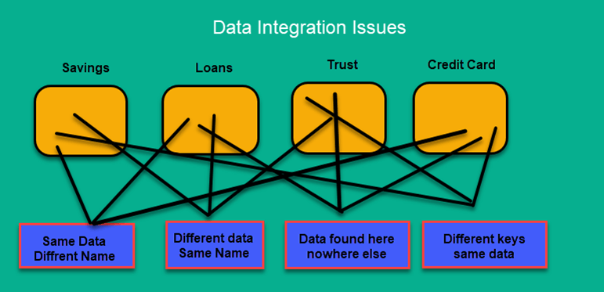Data Integration Issues
Following are Data Integrity Problems:
- Different spelling of the same person like Jon, John, etc.
- There are multiple ways to denote company name like Google, Google Inc.
- Use of different names like Cleaveland, Cleveland.
- There may be a case that different account numbers are generated by various applications for the same customer.
- In some data required files remains blank
- Invalid product collected at POS as manual entry can lead to mistakes.
Validations are done during this stage
- Filtering – Select only certain columns to load
- Using rules and lookup tables for Data standardization
- Character Set Conversion and encoding handling
- Conversion of Units of Measurements like Date Time Conversion, currency conversions, numerical conversions, etc.
- Data threshold validation check. For example, age cannot be more than two digits.
- Data flow validation from the staging area to the intermediate tables.
- Required fields should not be left blank.
- Cleaning ( for example, mapping NULL to 0 or Gender Male to “M” and Female to “F” etc.)
- Split a column into multiples and merging multiple columns into a single column.
- Transposing rows and columns,
- Use lookups to merge data
- Using any complex data validation (e.g., if the first two columns in a row are empty then it automatically reject the row from processing)

Step 3) Loading
Loading data into the target datawarehouse database is the last step of the ETL process. In a typical Data warehouse, huge volume of data needs to be loaded in a relatively short period (nights). Hence, load process should be optimized for performance.
In case of load failure, recover mechanisms should be configured to restart from the point of failure without data integrity loss. Data Warehouse admins need to monitor, resume, cancel loads as per prevailing server performance.
Types of Loading:
- Initial Load — populating all the Data Warehouse tables
- Incremental Load — applying ongoing changes as when needed periodically.
- Full Refresh —erasing the contents of one or more tables and reloading with fresh data.

Load verification
- Ensure that the key field data is neither missing nor null.
- Test modeling views based on the target tables.
- Check that combined values and calculated measures.
- Data checks in dimension table as well as history table.
- Check the BI reports on the loaded fact and dimension table.

ETL Tools
There are many ETL tools are available in the market. Here, are some most prominent one:
1. MarkLogic:
MarkLogic is a data warehousing solution which makes data integration easier and faster using an array of enterprise features. It can query different types of data like documents, relationships, and metadata.
https://www.marklogic.com/product/getting-started/
Conclusion:-

